# **26. OSPF: PART 1 (IGP: LINK STATE)**

### **LINK STATE ROUTING PROTOCOLS**

* **Purpose**: Every router creates a "connectivity map" of the network.
* **How It Works**:  
  + Each router advertises its interfaces (connected networks) to its neighbors.
  + These advertisements are passed along to other routers until all routers develop the same map of the network.
  + Each router independently calculates the best routes to each destination using this map.
* **Advantages of Link State Protocols**:
  + React faster to network changes than Distance Vector Protocols.
* **Disadvantages**:
  + Higher resource usage (CPU, memory).

### **BASIC OSPF OPERATIONS**

* **OSPF** stands for **Open Shortest Path First**.
* **Algorithm**: Shortest Path First (SPF), also known as **Dijkstra’s Algorithm**, developed by Edsger Dijkstra. *(Possible exam question)*

#### **OSPF Versions:**

* **OSPFv1 (1989)**: Obsolete.
* **OSPFv2 (1998)**: For IPv4.
* **OSPFv3 (2008)**: For IPv6 (can also support IPv4 but OSPFv2 is preferred).

#### **Key Concepts:**

* Routers store network information in **Link State Advertisements (LSAs)**.
* LSAs are organized into a **Link State Database (LSDB)**.
* LSAs are **flooded** throughout the OSPF area to ensure all routers share the same LSDB.
* **Aging Timer**: LSAs have a default aging timer of **30 minutes**; LSAs are re-flooded when the timer expires.

#### **OSPF Process:**

1. **Become neighbors** with other routers in the same segment.
2. **Exchange LSAs** with neighbor routers.
3. **Calculate the best routes** to each destination and update the routing table.

### **OSPF AREAS**

* **Purpose**: Divide the network into smaller segments for scalability.

#### **Small Networks:**

* Single-area designs work fine.

#### **Large Networks:**

* Single-area designs can lead to performance issues:
  + Slower SPF calculations.
  + High processing power required on routers.
  + Large LSDBs consume memory.
  + Frequent network changes cause excessive LSA flooding and SPF recalculations.

#### **Solution: Divide into multiple areas:**

* **Area**: Set of routers and links sharing the same LSDB.
* **Backbone Area (Area 0)**: Central area all other areas must connect to.

#### **Router Types:**

* **Internal Router**: All interfaces in the same area.
* **Area Border Router (ABR)**: Interfaces in multiple areas.
  + **Note**:
    - ABRs maintain separate LSDBs for each connected area.
    - Connect ABRs to a maximum of two areas to avoid overburdening.
* **Backbone Router**: Connected to the backbone area (Area 0).
* **Autonomous System Boundary Router (ASBR)**: One interface is in OSPF and Other Interface is in any other Routing Protocol Domain

#### **Route Types:**

* **Intra-Area Route**: Destination within the same OSPF area.
* **Inter-Area Route**: Destination in a different OSPF area.

### **OSPF RULES**

1. Areas must be contiguous (no split areas). E.g. Area 1 - Area 2 - Area 1
2. All areas must have at least one ABR connected to the backbone area.
3. OSPF interfaces in the same subnet must belong to the same area.

### **BASIC OSPF CONFIGURATION**

#### **Example: Single-Area OSPF (Area 0)**

1. **OSPF Process ID**: Locally significant; routers with different Process IDs can still become neighbors.
2. **Network Command**:
   * Specifies the area (e.g., area 0).
   * Activates OSPF on interfaces matching the IP range.
   * Triggers routers to become OSPF neighbors.

#### **Example Commands:**

R1(config)#router ospf <Process ID from 1-65535>

R1(config-router) network 192.168.1.0 0.0.0.255 area 0

#### **Passive-Interface Command:**

R1(config-router) passive-interface g2/0

* Prevents sending OSPF "hello" messages out an interface.
* LSAs for the subnet are still sent.
* **Use Case**: Apply to interfaces without OSPF neighbors.

### **SHOW COMMANDS FOR OSPF**

1. **show ip protocols**: Verifies OSPF configuration.
2. **Default Administrative Distance (AD)**:
   * OSPF = 110 (can be changed with the distance command).f

R1(config-router)#distance ?

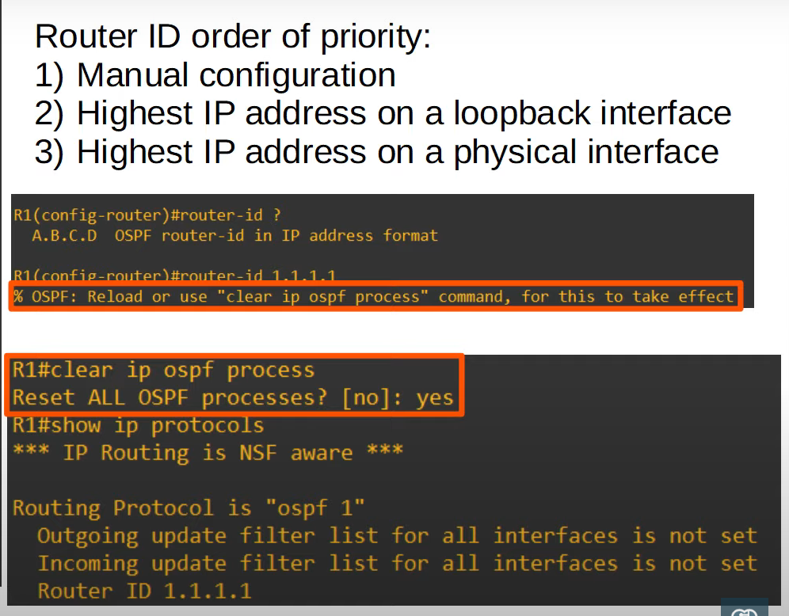

*only do this for labs*